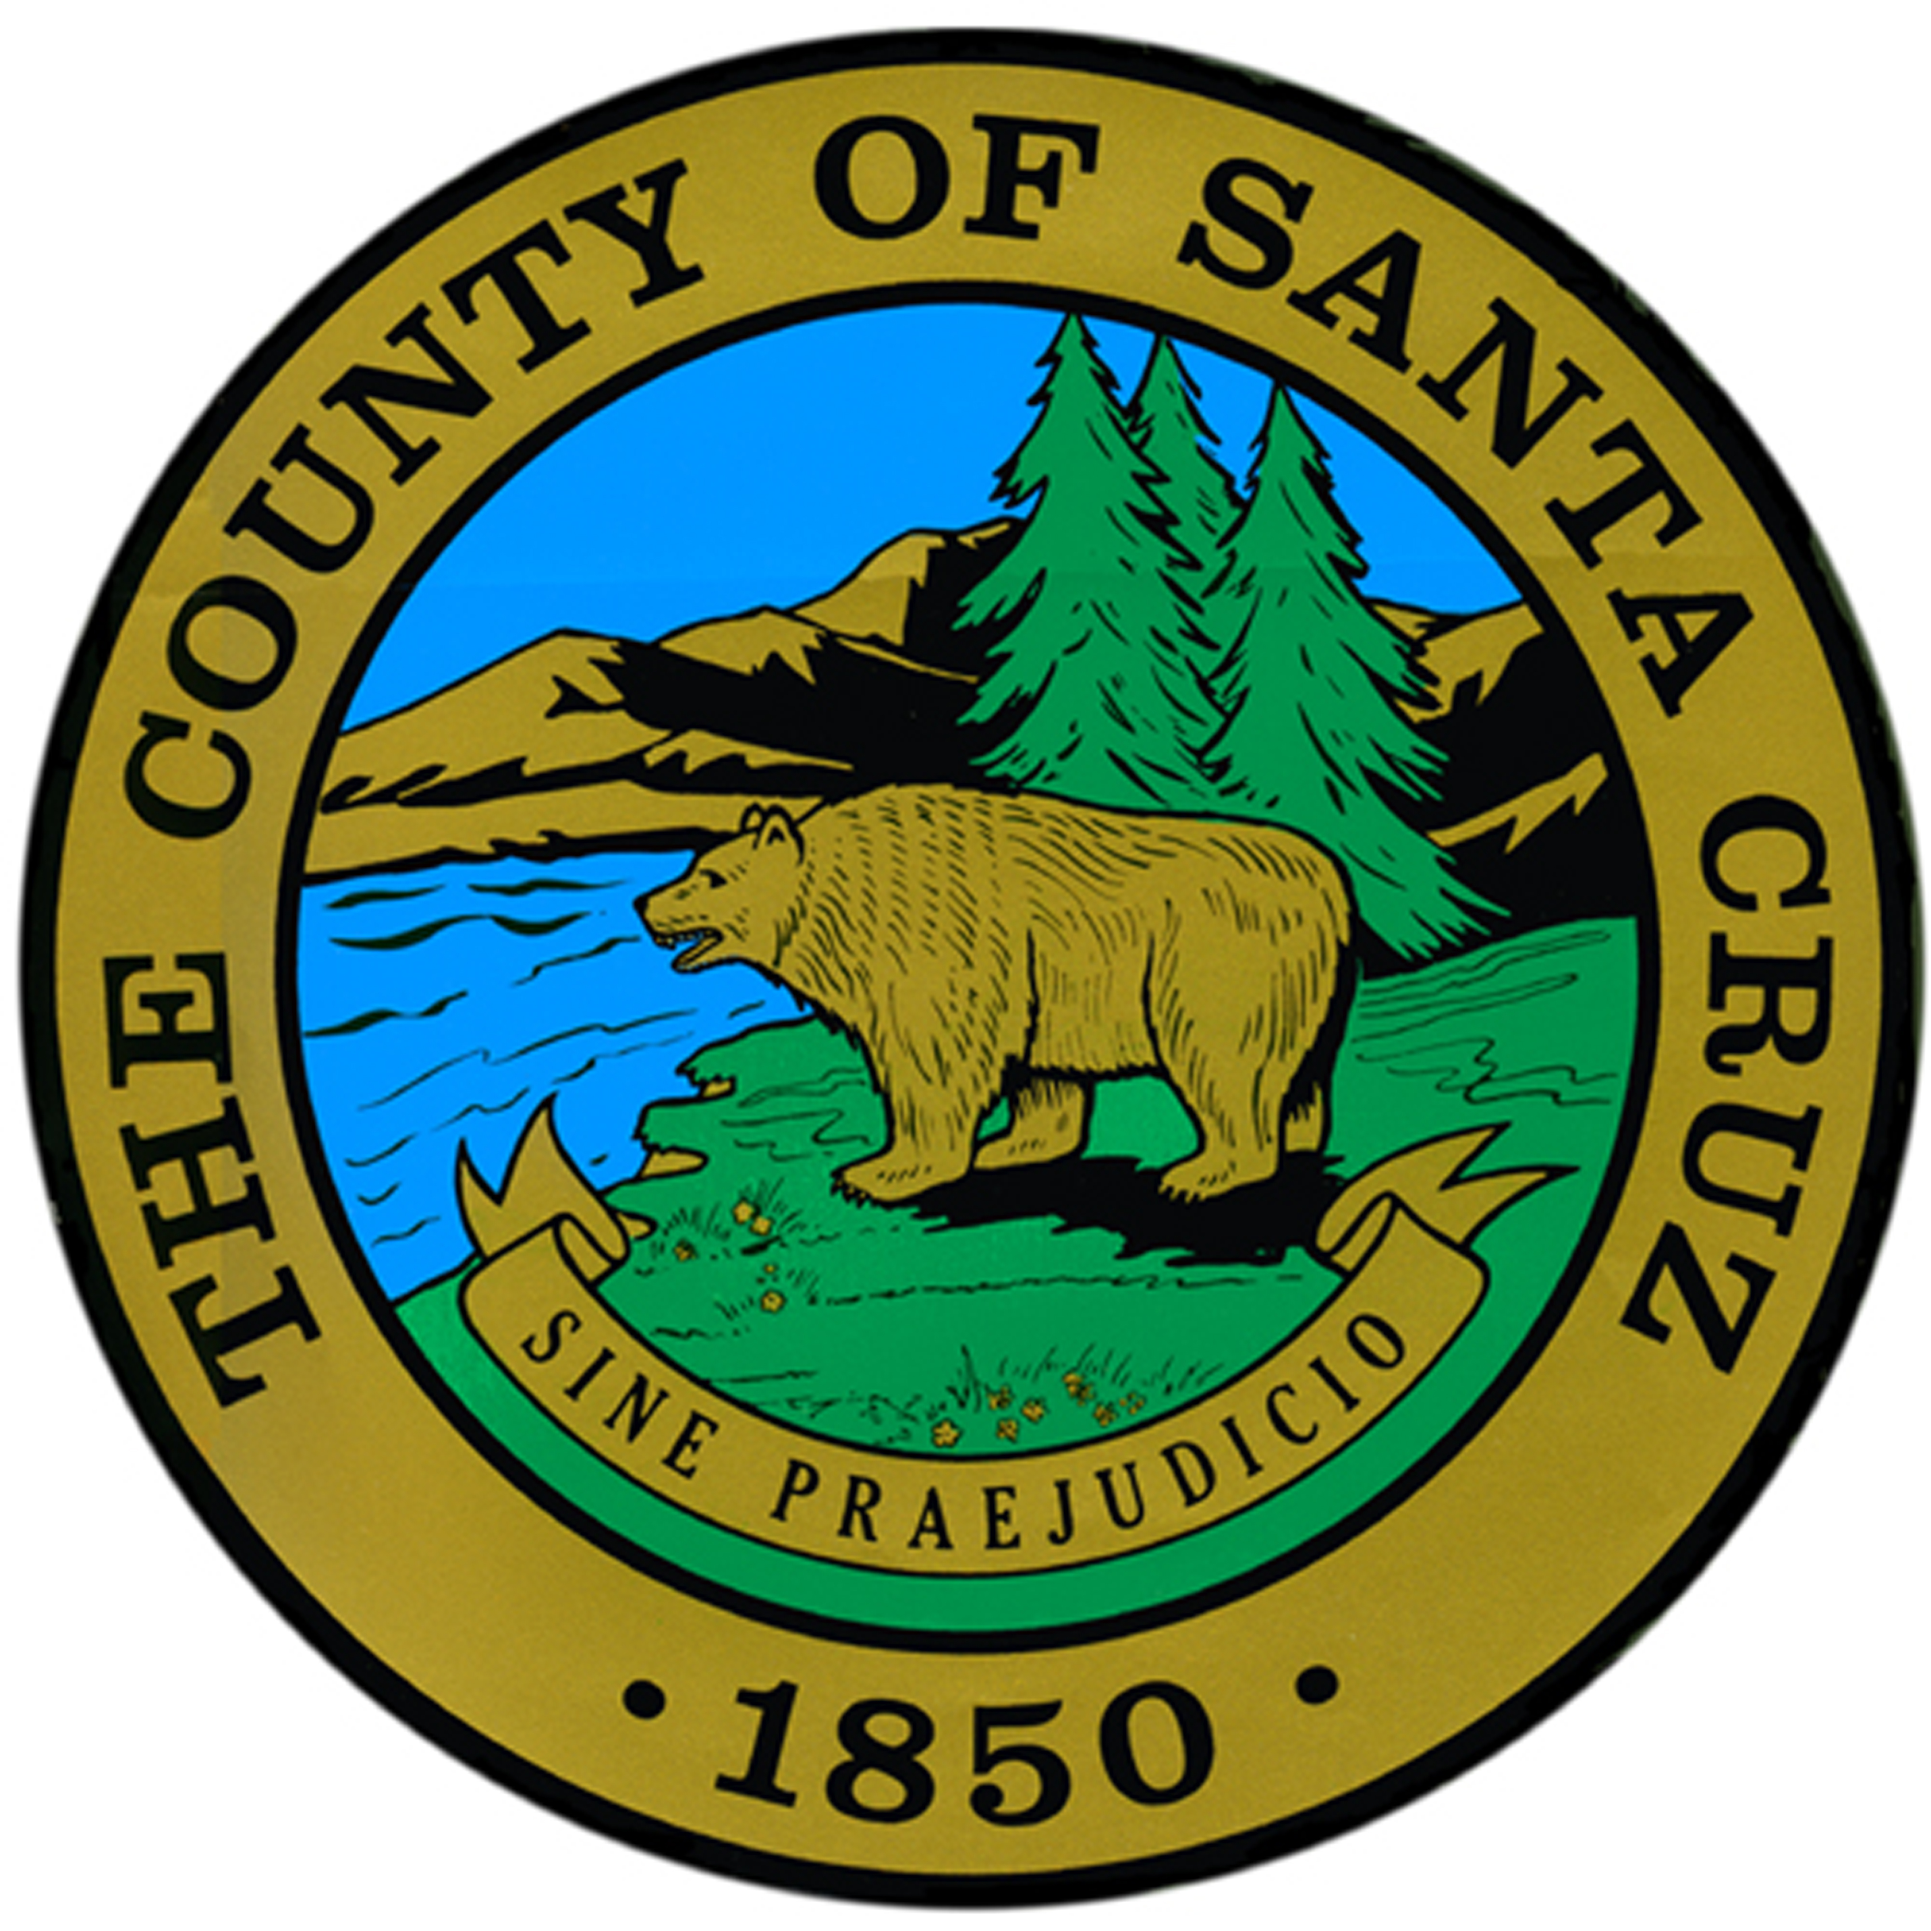
System No. 4400
Attachment A

WATER QUALITY EMERGENCY NOTIFICATION PLAN

Name of Water System:
Physical Location Address:

The following persons have been designated to implement the plan upon notification by the Division of Drinking Water and/or County of Santa Cruz that an imminent danger to the health of the water users exists:
Water System:  Contact Name & Title |  | Email Address | Telephone
 |  | Email Address | Day | Evening | Cell
1.
2.
3.

The implementation of the plan will be carried out with the following Division of Drinking Water and County Health personnel:
Contact Name & Title |  | Telephone
1. | Nathan Salazar, Drinking Water Program,  County of Santa Cruz Health Services Agency, Environmental Health Division | (831) 359-0856
2. | County of Santa Cruz Health Services Agency, Environmental Health Division | (831) 454-2022
3. | Monterey Office, State Water Resources Control Board, Division of Drinking Water | (831) 655-6939
4. If the above personnel cannot be reached, contact:
Office of Emergency Services (24 Hrs.)  Ask for “Division of Drinking of Water, Duty Officer” | (800) 852-7550 or (916) 845-8911

NOTIFICATION PLAN
STANDARD PLAN: Please check if you agree to notify customers by door-to-door contact or written handout sheets. It is important that the people going door-to-door are coordinated and trained so they distribute copies to the designated areas of the water system. Maps of the specific areas that the notices are to be distributed should be provided to the customers.

ALTERNATE PLAN: Please check if you propose to use another method, and attach the alternate plan to this form.

Report prepared by:

___________________________________________ ___________________________
Signature and Title Date

